Digital System Design
Verilog Assignment
Semester III

UNIVERSITY OF DELHI
FACULTY OF TECHNOLOGY

Submitted To: Dr. Khushwant Sehra (Assistant Professor, ECE Department)
Submitted By: Manav Bhatia
Branch: Computer Science and Engineering (CSE-A)
Roll No. 24293916122
Enrollment No. 24DOCEBTCS000122

Ques. Writing Source, Testbench Codes and Running Simulations for the following:
- Basic Gates
- Boolean Expressions
- Multiplexers (4 x 1 and 8 x 1)
- Priority Encoder
- Decoder
- Half Adder and Full Adder
- Half Subtractor and Full Subtractor
- Universal Adder / Subtractor with Overflow Check
- SR Latch
- SR and JK - Flip Flop
- D and T - Flip Flop
- Counter Design
Ans.
- Basic Gates
- AND Gate
Source Code:
`timescale 1ns/1ps
module and_gate (
input wire a,
input wire b,
output wire y
);
assign y = a & b;
endmodule

Testbench Code:
`timescale 1ns/1ps
module tb_and_gate;
reg a, b;
wire y;
// Instantiate AND gate module
and_gate uut (
.a(a),
.b(b),
.y(y)
);
initial begin
a = 0; b = 0; #10;
a = 0; b = 1; #10;
a = 1; b = 0; #10;
a = 1; b = 1; #10;
$finish;
end
endmodule
Simulation:
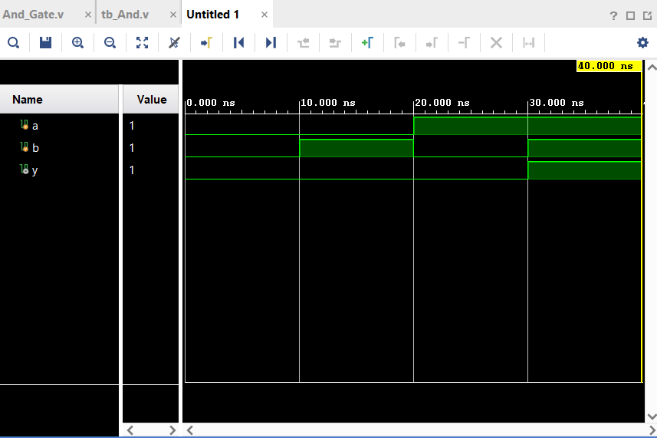
RTL Synthesis:
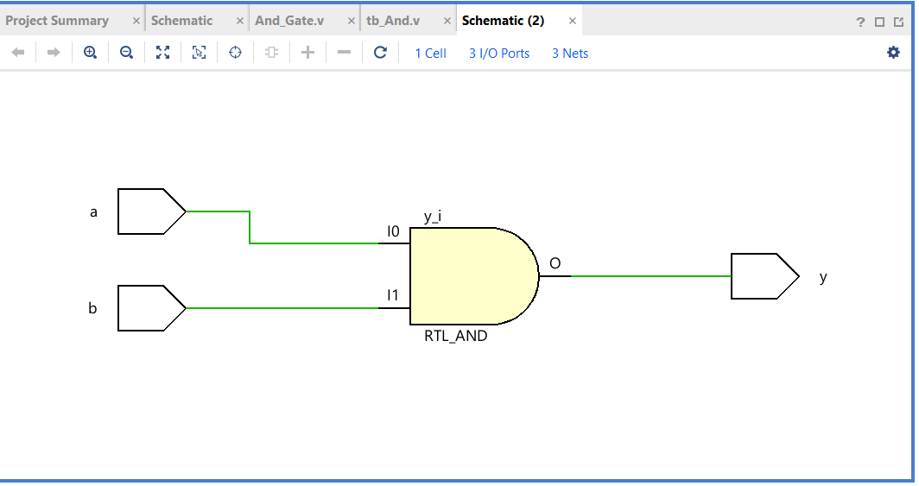
- OR Gate
Source Code:
`timescale 1ns/1ps
module or_gate (
input wire a,
input wire b,
output wire y
);
assign y = a | b;
endmodule
Testbench Code:
`timescale 1ns / 1ps

module tb_or_gate;

reg a, b;
wire y;

// Instantiate OR gate module
or_gate uut (
.a(a),
.b(b),
.y(y)
);

initial begin
a = 0; b = 0; #10;
a = 0; b = 1; #10;
a = 1; b = 0; #10;
a = 1; b = 1; #10;

$finish;
end

endmodule
Simulation:
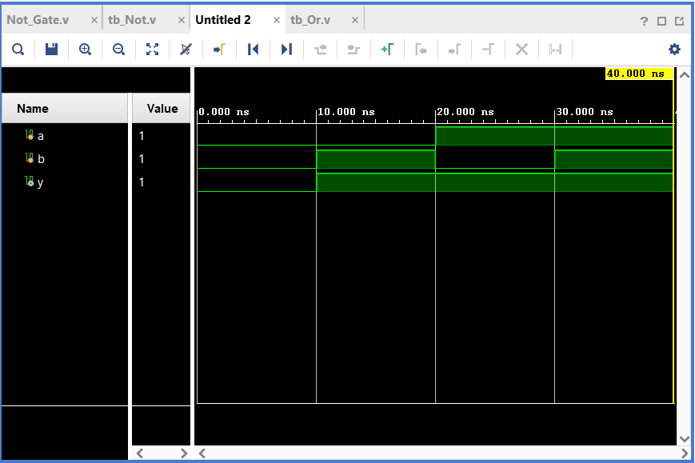
RTL Synthesis:
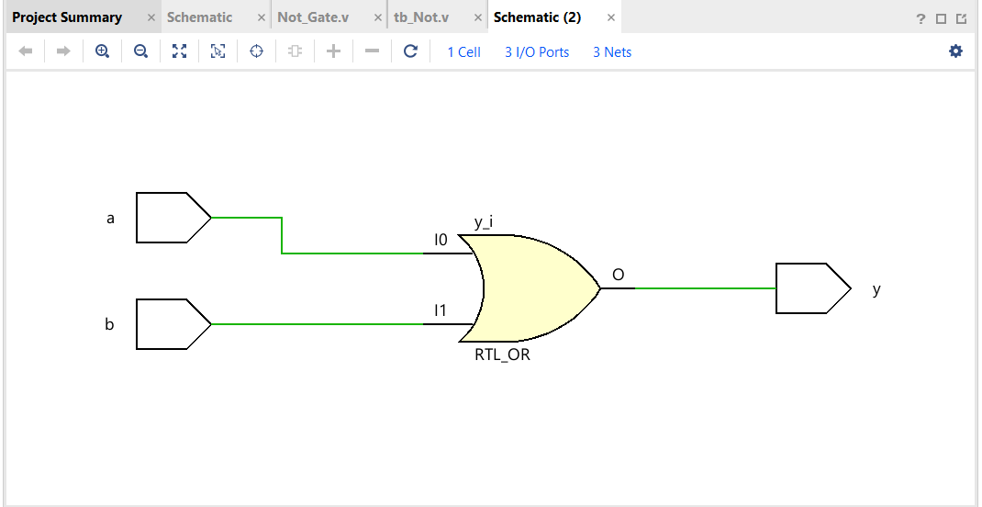
- NOT Gate
Source Code:
`timescale 1ns/1ps
module not_gate (
input wire a,
output wire y
);
assign y = ~a;
endmodule
Testbench Code:
`timescale 1ns / 1ps

module tb_not_gate;

reg a;
wire y;

// Instantiate NOT gate module
not_gate uut (
.a(a),
.y(y)
);

initial begin
a = 0; #10;
a = 1; #10;

$finish;
end

endmodule
Simulation:
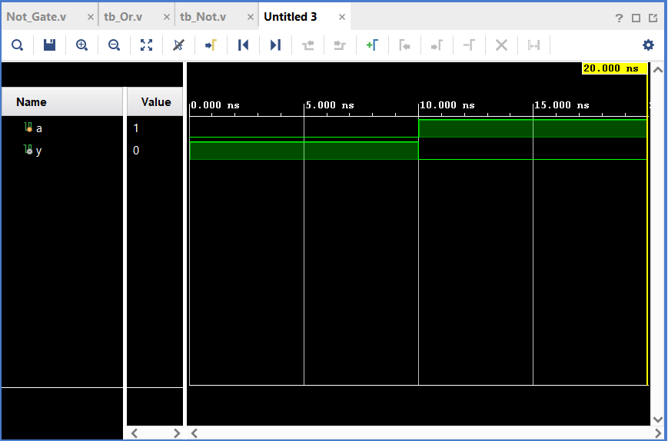
RTL Synthesis:
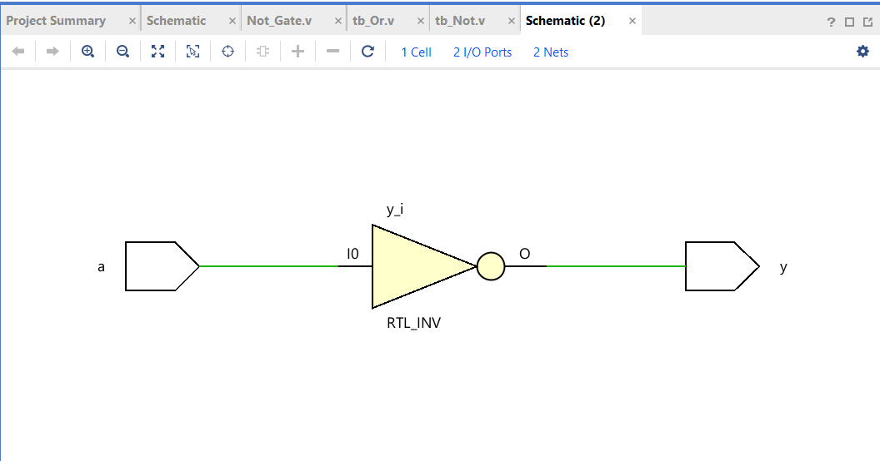
- NAND Gate
Source Code:
`timescale 1ns/1ps
module nand_gate (
input wire a,
input wire b,
output wire y
);
assign y = ~(a & b);
endmodule
Testbench Code:
`timescale 1ns / 1ps

module tb_nand_gate;

reg a, b;
wire y;

// Instantiate NAND gate module
nand_gate uut (
.a(a),
.b(b),
.y(y)
);

initial begin
a = 0; b = 0; #10;
a = 0; b = 1; #10;
a = 1; b = 0; #10;
a = 1; b = 1; #10;

$finish;
end

endmodule
Simulation:
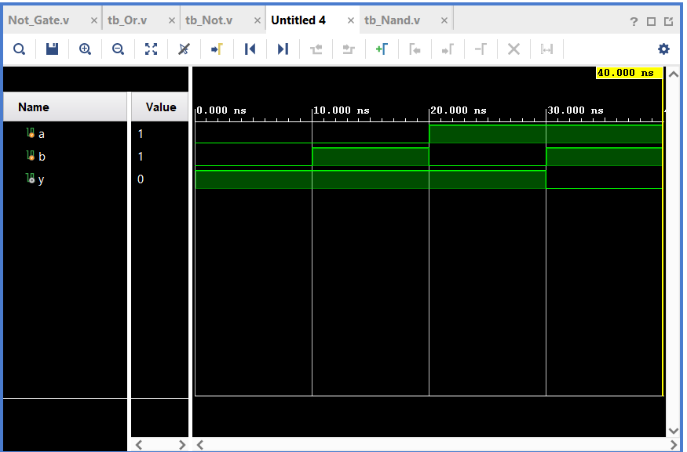
RTL Synthesis:
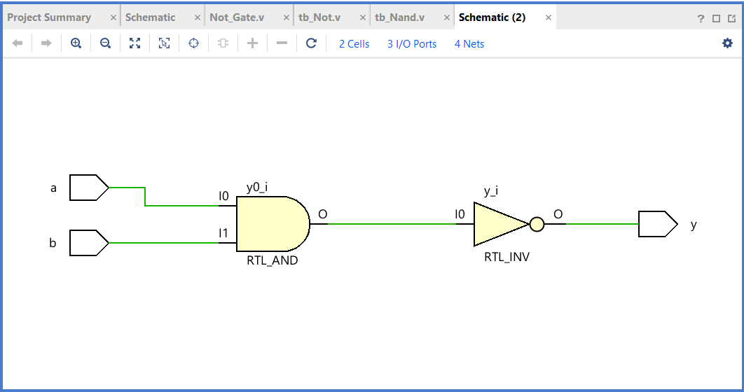

- NOR Gate
Source Code:
`timescale 1ns/1ps
module nor_gate (
input wire a,
input wire b,
output wire y
);
assign y = ~(a | b);
endmodule
Testbench Code:
`timescale 1ns / 1ps

module tb_nor_gate;

reg a, b;
wire y;

// Instantiate NOR gate module
nor_gate uut (
.a(a),
.b(b),
.y(y)
);

initial begin
a = 0; b = 0; #10;
a = 0; b = 1; #10;
a = 1; b = 0; #10;
a = 1; b = 1; #10;

$finish;
end

endmodule
Simulation:
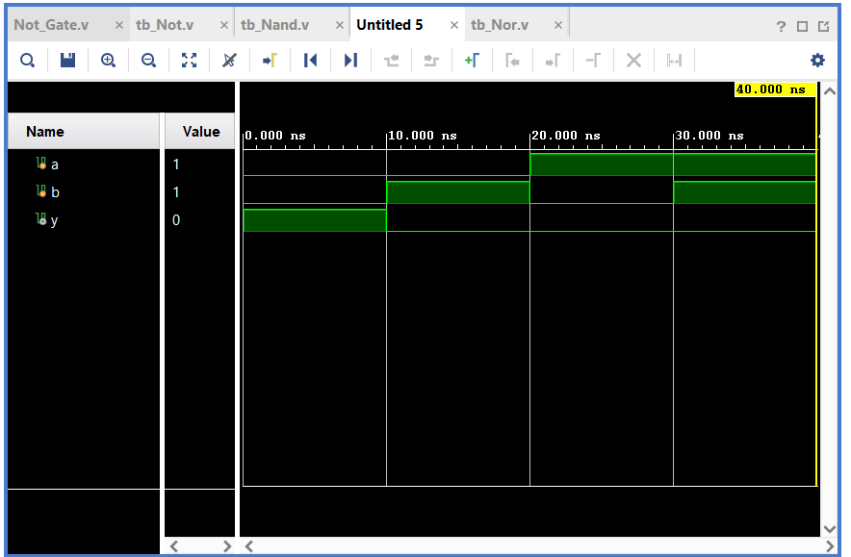
RTL Synthesis:
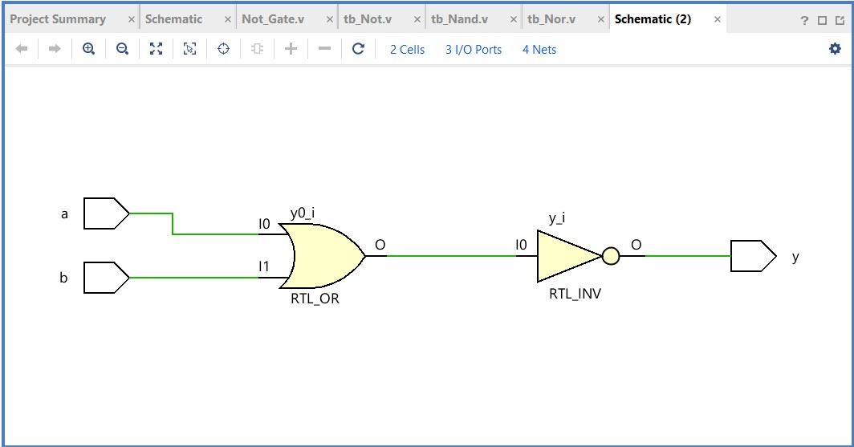
- XOR Gate
Source Code:
`timescale 1ns/1ps
module xor_gate (
input wire a,
input wire b,
output wire y
);
assign y = a ^ b;
endmodule
Testbench Code:
`timescale 1ns / 1ps

module tb_xor_gate;

reg a, b;
wire y;

// Instantiate XOR gate module
xor_gate uut (
.a(a),
.b(b),
.y(y)
);

initial begin
a = 0; b = 0; #10;
a = 0; b = 1; #10;
a = 1; b = 0; #10;
a = 1; b = 1; #10;

$finish;
end

endmodule
Simulation:
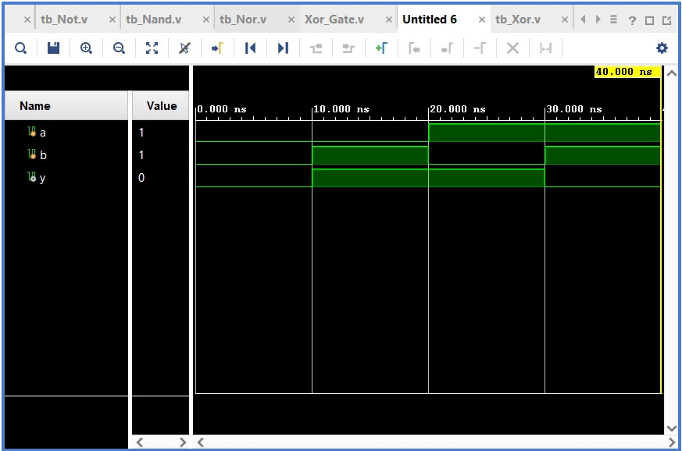
RTL Synthesis:
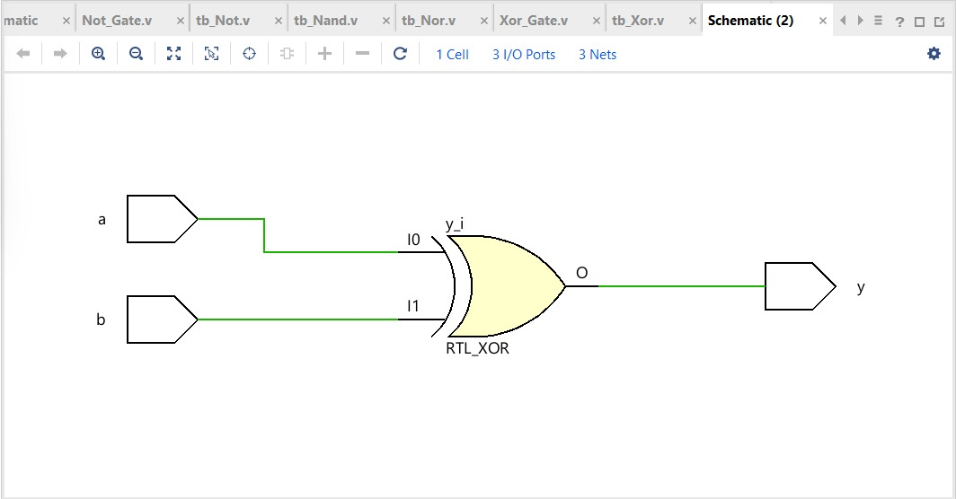
- XNOR Gate
Source Code:
`timescale 1ns/1ps
module xnor_gate (
input wire a,
input wire b,
output wire y
);
assign y = ~(a ^ b);
endmodule
Testbench Code:
`timescale 1ns / 1ps

module tb_xnor_gate;

reg a, b;
wire y;

// Instantiate XNOR gate module
xnor_gate uut (
.a(a),
.b(b),
.y(y)
);

initial begin
a = 0; b = 0; #10;
a = 0; b = 1; #10;
a = 1; b = 0; #10;
a = 1; b = 1; #10;

$finish;
end

endmodule
Simulation: 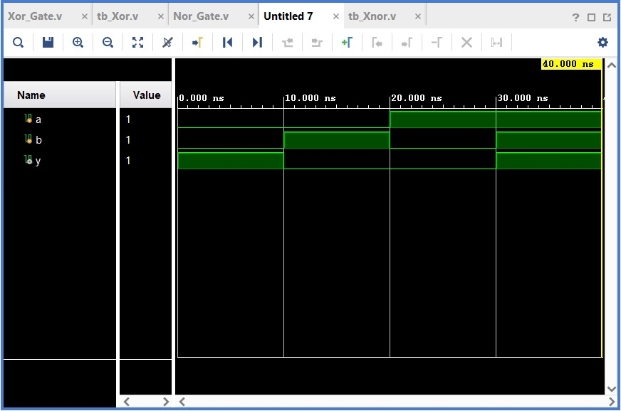
RTL Synthesis:
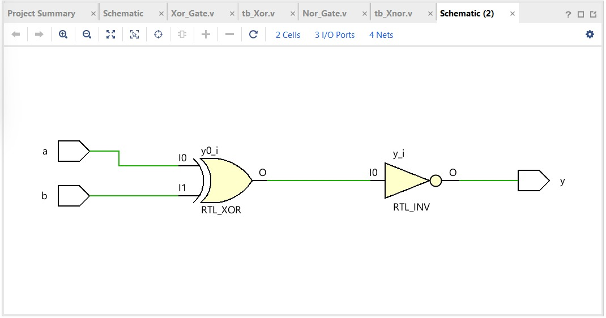

- Boolean Expressions
- Simple Behavioural
Source Code:
module bool_expr_beh(input a, input b, input c, output y);
assign y = (a & b) | (~c);
endmodule
Testbench Code:
`timescale 1ns/1ps

module tb_bool_expr_beh;

reg a, b, c;
wire y;

bool_expr_beh uut(
.a(a),
.b(b),
.c(c),
.y(y)
);

initial begin
a = 0; b = 0; c = 0; #10;
a = 0; b = 0; c = 1; #10;
a = 0; b = 1; c = 0; #10;
a = 0; b = 1; c = 1; #10;
a = 1; b = 0; c = 0; #10;
a = 1; b = 0; c = 1; #10;
a = 1; b = 1; c = 0; #10;
a = 1; b = 1; c = 1; #10;

$finish;
end

endmodule
Simulation:
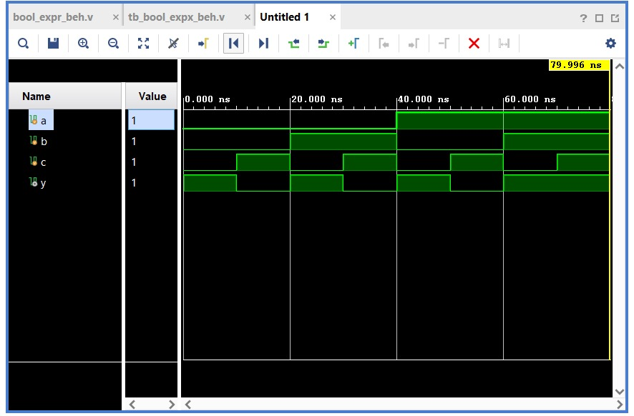
RTL Synthesis:
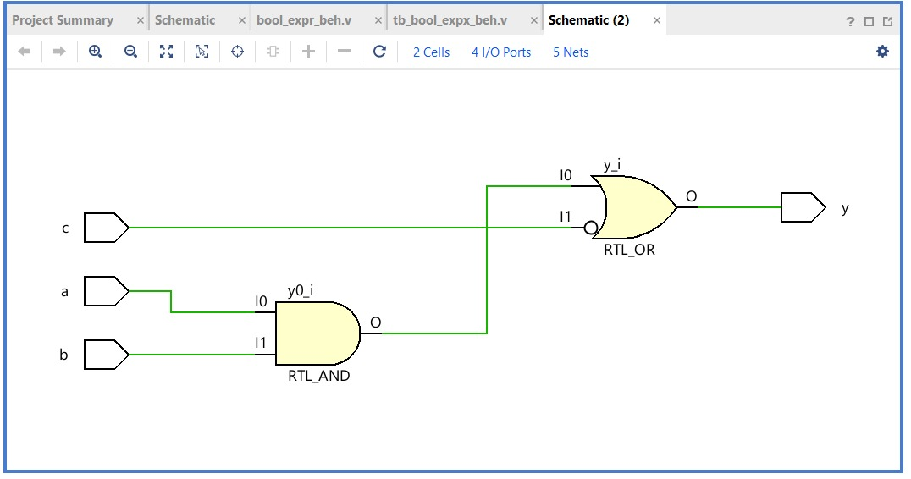
- Complex Behavioural
Source Code:
module bool_expr_complex_beh(input a, input b, input c, input d, output y);
assign y = (a & b) | (c ^ d) & (~a | b);
endmodule
Testbench Code:
`timescale 1ns/1ps

module tb_bool_expr_complex_beh;

reg a, b, c, d;
wire y;

bool_expr_complex_beh uut(
.a(a),
.b(b),
.c(c),
.d(d),
.y(y)
);

initial begin
a=0; b=0; c=0; d=0; #10;
a=0; b=0; c=0; d=1; #10;
a=0; b=0; c=1; d=0; #10;
a=0; b=0; c=1; d=1; #10;
a=0; b=1; c=0; d=0; #10;
a=0; b=1; c=0; d=1; #10;
a=0; b=1; c=1; d=0; #10;
a=0; b=1; c=1; d=1; #10;
a=1; b=0; c=0; d=0; #10;
a=1; b=0; c=0; d=1; #10;
a=1; b=0; c=1; d=0; #10;
a=1; b=0; c=1; d=1; #10;
a=1; b=1; c=0; d=0; #10;
a=1; b=1; c=0; d=1; #10;
a=1; b=1; c=1; d=0; #10;
a=1; b=1; c=1; d=1; #10;

$finish;
end

endmodule
Simulation:
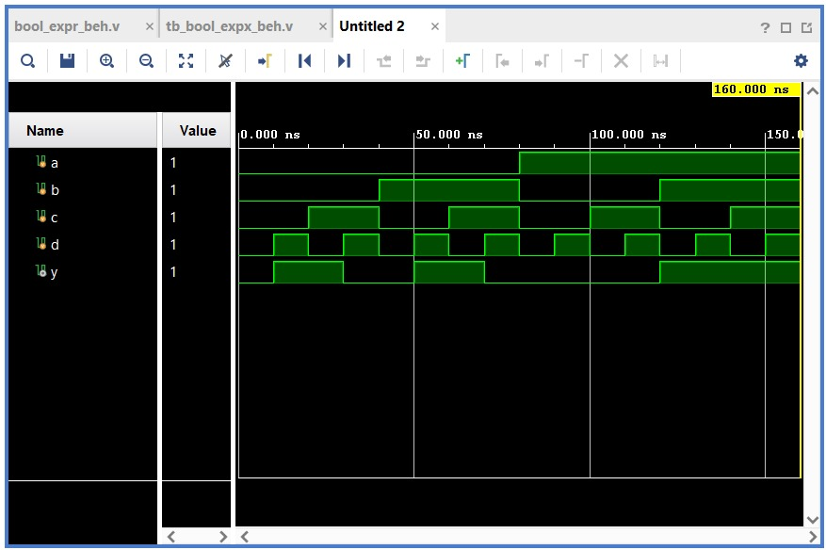
RTL Synthesis:
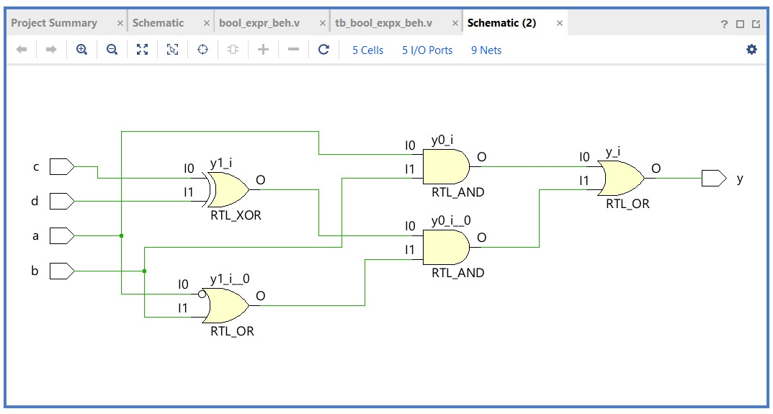
- Simple Structural
Source Code:
`timescale 1ns / 1ps
module bool_expr_struct(input a, input b, input c, output y);
wire w1, w2;

and (w1, a, b);
not (w2, c);
or (y, w1, w2);
endmodule
Testbench Code:
`timescale 1ns/1ps

module tb_bool_expr_struct;

reg a, b, c;
wire y;

bool_expr_struct uut(
.a(a),
.b(b),
.c(c),
.y(y)
);

initial begin
a=0; b=0; c=0; #10;
a=0; b=0; c=1; #10;
a=0; b=1; c=0; #10;
a=0; b=1; c=1; #10;
a=1; b=0; c=0; #10;
a=1; b=0; c=1; #10;
a=1; b=1; c=0; #10;
a=1; b=1; c=1; #10;

$finish;
end

endmodule
Simulation:
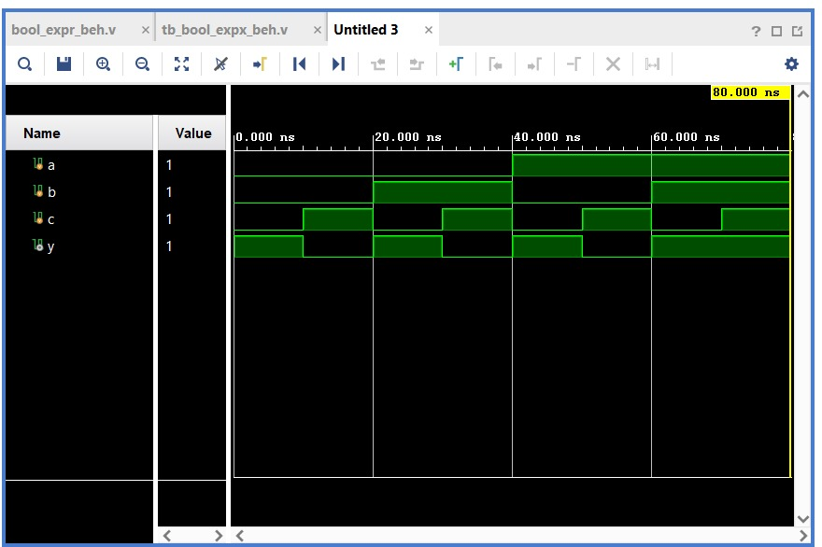
RTL Synthesis:
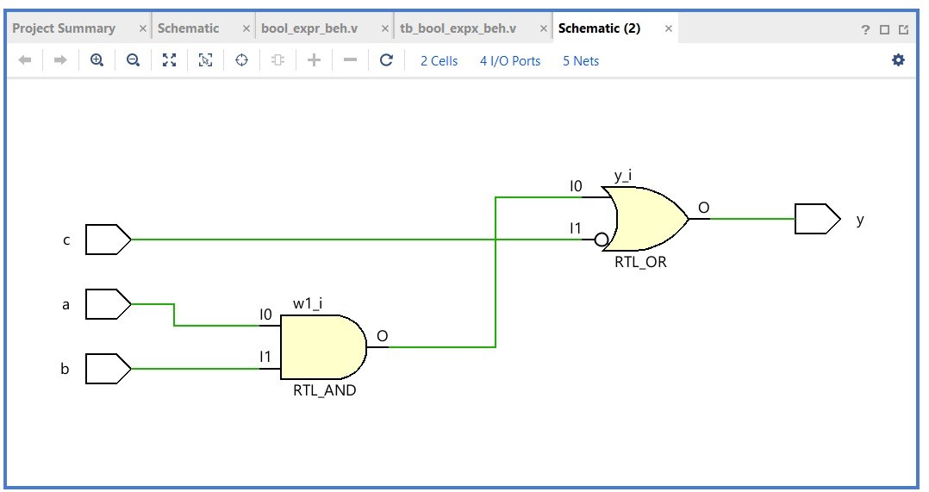
- Complex Structural
Source Code:
module bool_expr_complex_struct(input a, input b, input c, input d, output y);
wire w1, w2, w3, w4, w5;

and (w1, a, b);
xor (w2, c, d);
or (w3, w1, w2);
not (w4, a);
or (w5, w4, b);
and (y, w5, w3);
endmodule
Testbench Code:
`timescale 1ns/1ps

module tb_bool_expr_complex_struct;

reg a, b, c, d;
wire y;

bool_expr_complex_struct uut(
.a(a),
.b(b),
.c(c),
.d(d),
.y(y)
);

initial begin
a=0; b=0; c=0; d=0; #10;
a=0; b=0; c=0; d=1; #10;
a=0; b=0; c=1; d=0; #10;
a=0; b=0; c=1; d=1; #10;
a=0; b=1; c=0; d=0; #10;
a=0; b=1; c=0; d=1; #10;
a=0; b=1; c=1; d=0; #10;
a=0; b=1; c=1; d=1; #10;
a=1; b=0; c=0; d=0; #10;
a=1; b=0; c=0; d=1; #10;
a=1; b=0; c=1; d=0; #10;
a=1; b=0; c=1; d=1; #10;
a=1; b=1; c=0; d=0; #10;
a=1; b=1; c=0; d=1; #10;
a=1; b=1; c=1; d=0; #10;
a=1; b=1; c=1; d=1; #10;

$finish;
end

endmodule
Simulation:
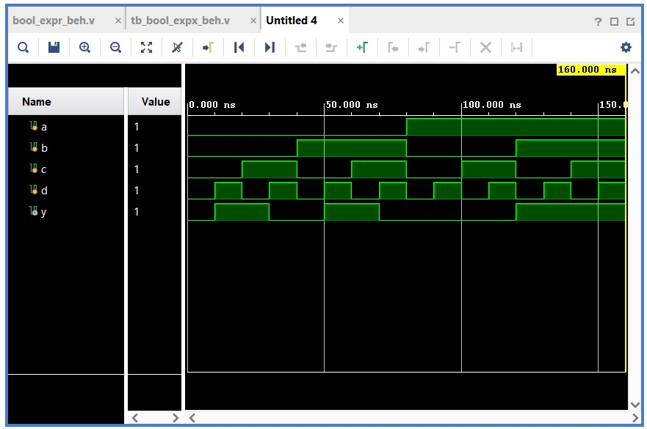
RTL Synthesis:
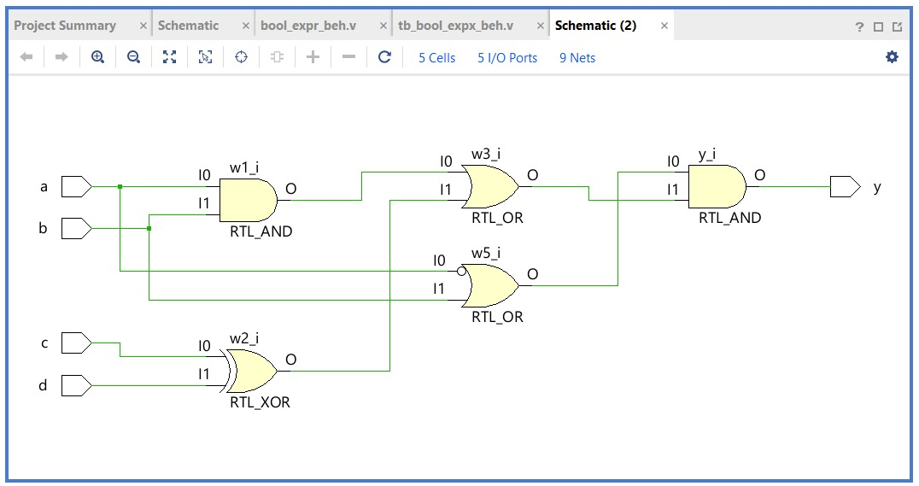
- Multiplexers (4 x 1 and 8 x 1)
- Mux 4x1
Source Code:
`timescale 1ns/1ps
module mux4to1 (
input wire [3:0] I, // 4 data inputs: I[3:0]
input wire [1:0] S, // 2 select lines: S[1:0]
output wire Y
);

assign Y = (S == 2'b00) ? I[0] :
(S == 2'b01) ? I[1] :
(S == 2'b10) ? I[2] :
I[3];

endmodule
Testbench Code:
module tb_mux4x1;

reg [3:0] I;
reg [1:0] S;
wire Y;

mux4x1 dut(I, S, Y);

initial begin
// Test all combinations
I = 4'b1010; // arbitrary pattern

S = 2'b00; #10;
S = 2'b01; #10;
S = 2'b10; #10;
S = 2'b11; #10;

$finish;
end

endmodule
Simulation:
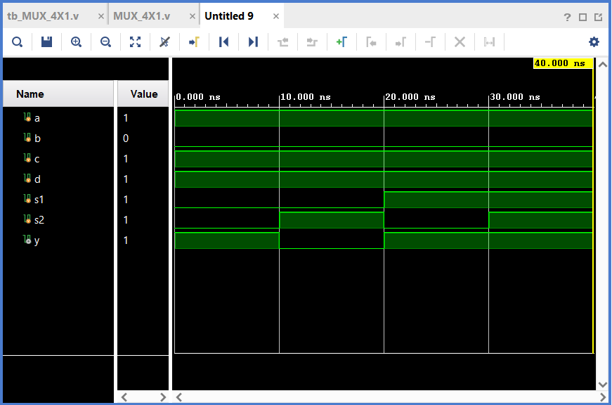
RTL Synthesis:
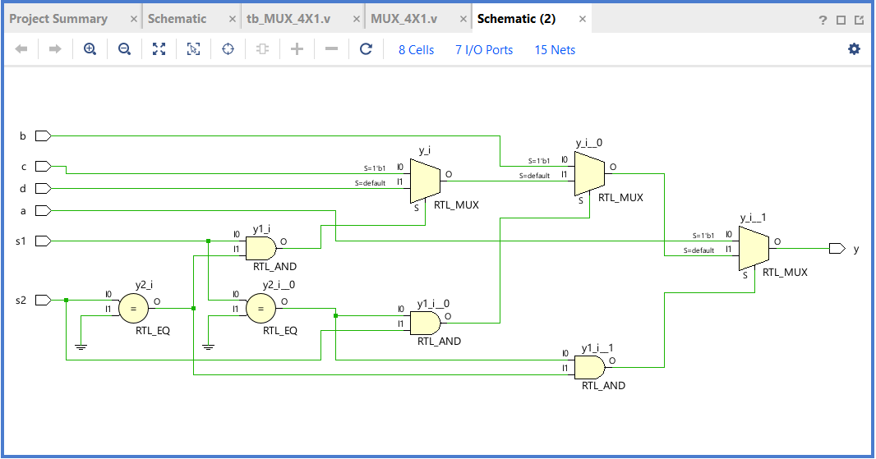
- Mux 8x1
Source Code:
`timescale 1ns / 1ps
module mux8to1(
input a, b, c, d, e, f, g, h,
input s1, s2, s3,
output reg y
);
always @(*) begin
if (s1 == 0 && s2 == 0 && s3 == 0) y = a;
else if (s1 == 0 && s2 == 0 && s3 == 1) y = b;
else if (s1 == 0 && s2 == 1 && s3 == 0) y = c;
else if (s1 == 0 && s2 == 1 && s3 == 1) y = d;
else if (s1 == 1 && s2 == 0 && s3 == 0) y = e;
else if (s1 == 1 && s2 == 0 && s3 == 1) y = f;
else if (s1 == 1 && s2 == 1 && s3 == 0) y = g;
else y = h;
end
endmodule
Testbench Code:
`timescale 1ns / 1ps
module tb_mux8to1();
reg a, b, c, d, e, f, g, h;
reg s1, s2, s3;
wire y;
mux8to1 uut(
.a(a), .b(b), .c(c), .d(d), .e(e), .f(f), .g(g), .h(h),
.s1(s1), .s2(s2), .s3(s3),
.y(y)
);
initial begin
a = 1; b = 1; c = 1; d = 1;
e = 1; f = 1; g = 1; h = 1;
s1 = 0; s2 = 0; s3 = 0; #10;
s1 = 0; s2 = 0; s3 = 1; #10;
s1 = 0; s2 = 1; s3 = 0; #10;
s1 = 0; s2 = 1; s3 = 1; #10;
s1 = 1; s2 = 0; s3 = 0; #10;
s1 = 1; s2 = 0; s3 = 1; #10;
s1 = 1; s2 = 1; s3 = 0; #10;
s1 = 1; s2 = 1; s3 = 1; #10;
$finish;
end
endmodule
Simulation:
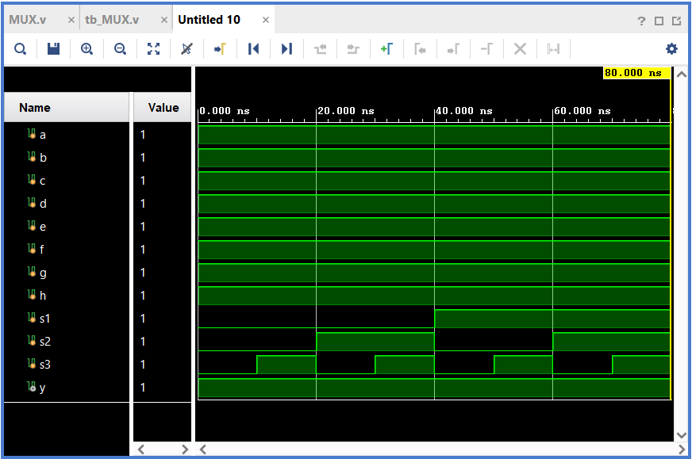
RTL Synthesis:
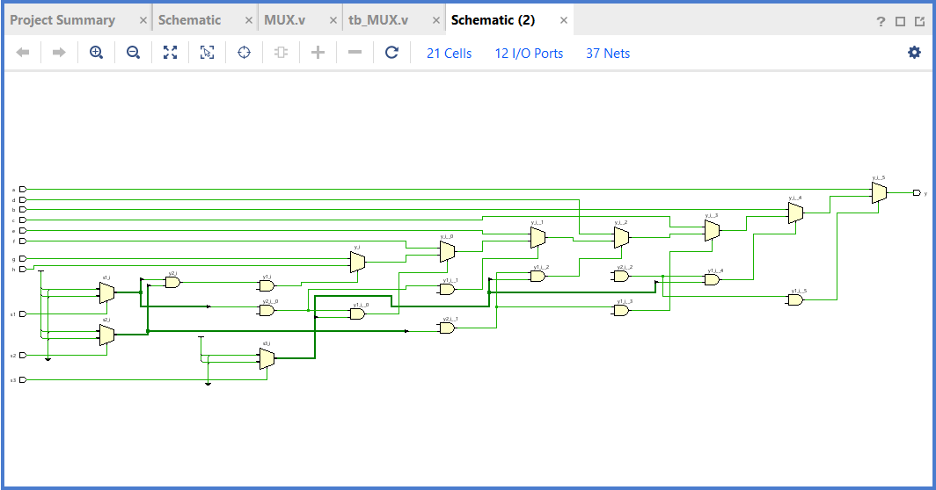

- Priority Encoder
- 4 to 2 Priority Encoder
Source Code:
`timescale 1ns / 1ps
module priority_encoder(
input d0,d1,d2,d3,
output a,b,v
);
assign a = d2|d3;
assign b=( d1 &(~d2))|d3;
assign v = d3|d2|d1|d0;
endmodule
Testbench Code:
`timescale 1ns / 1ps

module tb_priority_encoder(
);
reg d0,d1,d2,d3;
wire a,b ,v;

priority_encoder uut(d0,d1,d2,d3,a,b,v);

initial
begin
d0=0; d1=0;d2=0;d3=0;
#10
d0=1; d1=0;d2=0;d3=0;
#10
d0=0; d1=1;d2=0;d3=0;
#10
d0=0; d1=0;d2=1;d3=0;
#10
d0=0; d1=0;d2=0;d3=1;
#10
d0=1; d1=1;d2=0;d3=0;
#10
d0=1; d1=1;d2=1;d3=0;
#10
d0=1; d1=1;d2=1;d3=1;
#10
d0=1; d1=0;d2=1;d3=0;
#10
d0=1; d1=0;d2=0;d3=1;
#10
d0=1; d1=0;d2=1;d3=1;
#10
d0=0; d1=0;d2=1;d3=1;
#10
d0=0; d1=1;d2=1;d3=1;
#10
d0=1; d1=1;d2=0;d3=1;
#10
d0=0; d1=1;d2=1;d3=0;
#10
d0=0; d1=1;d2=0;d3=1;
#10

$finish;
end
endmodule
Simulation:
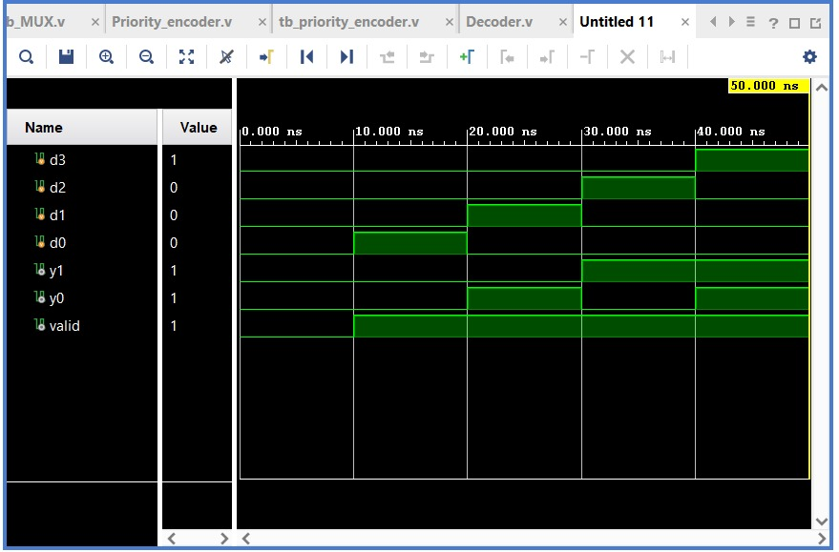
RTL Synthesis:
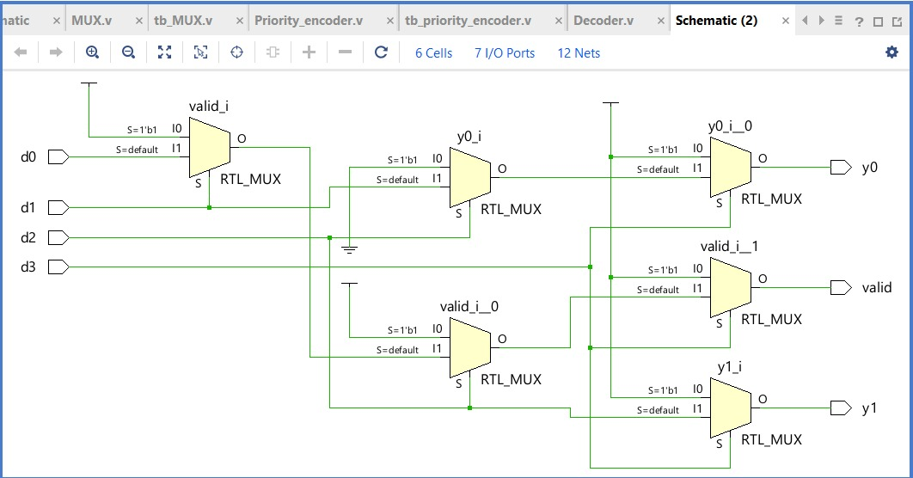
- Decoder (2 to 4)
Source Code:
`timescale 1ns / 1ps
module decoder(
input a,b,
output d0,d1,d2,d3
);
assign d0 = ~a&(~b);
assign d1 = ~a&b;
assign d2 = a&(~b);
assign d3 = a&b;
endmodule
Testbench Code:
`timescale 1ns / 1ps

module tb_decoder(
);
reg a,b;
wire d0,d1,d2,d3;

decoder uut(a,b,d0,d1,d2,d3);

initial
begin
a =0; b=0;
#10
a =0; b=1;
#10
a =1; b=0;
#10
a =1; b=1;
#10
$finish;
end
endmodule
Simulation:
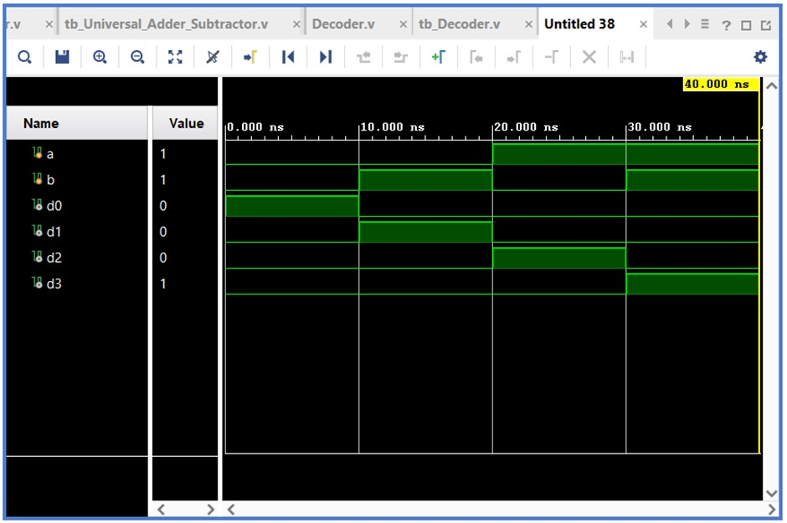
RTL Synthesis:
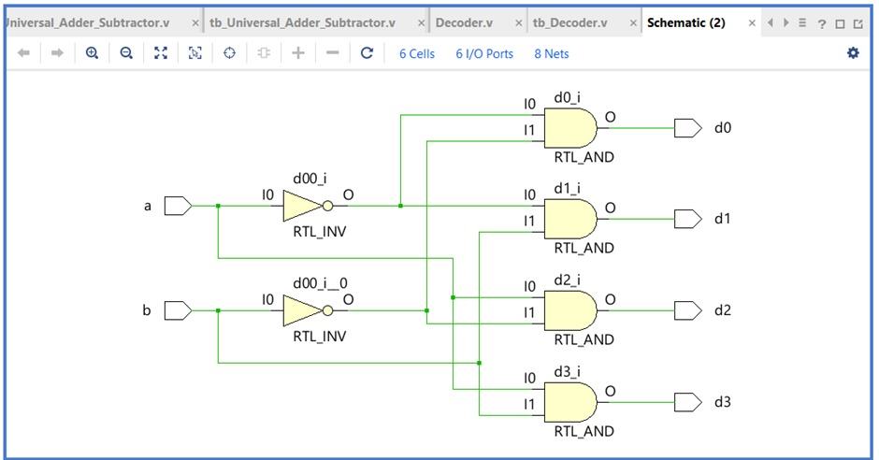
- Half Adder
Source Code:
`timescale 1ns / 1ps
module half_adder(
input a, b,
output sum, carry
);
assign sum = a ^ b;
assign carry = a & b;
endmodule
Testbench Code:
`timescale 1ns / 1ps
module tb_half_adder;
reg a, b;
wire sum, carry;

half_adder dut(a, b, sum, carry);

initial begin
$display("A B | SUM CARRY");
a = 0; b = 0; #10;
a = 0; b = 1; #10;
a = 1; b = 0; #10;
a = 1; b = 1; #10;
$finish;
end

endmodule
Simulation:
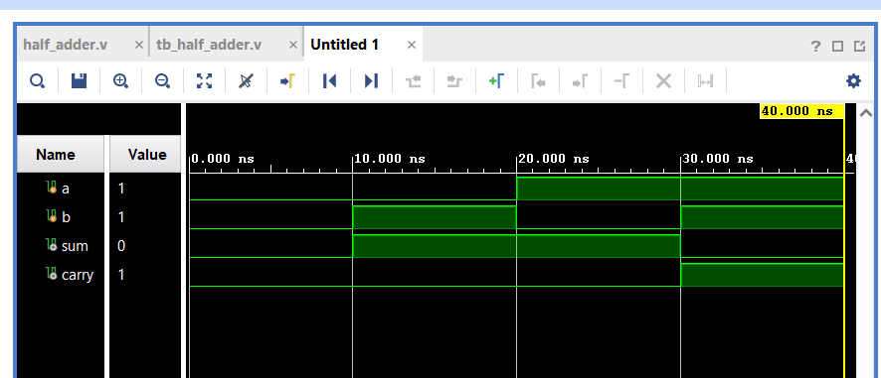
RTL Synthesis:
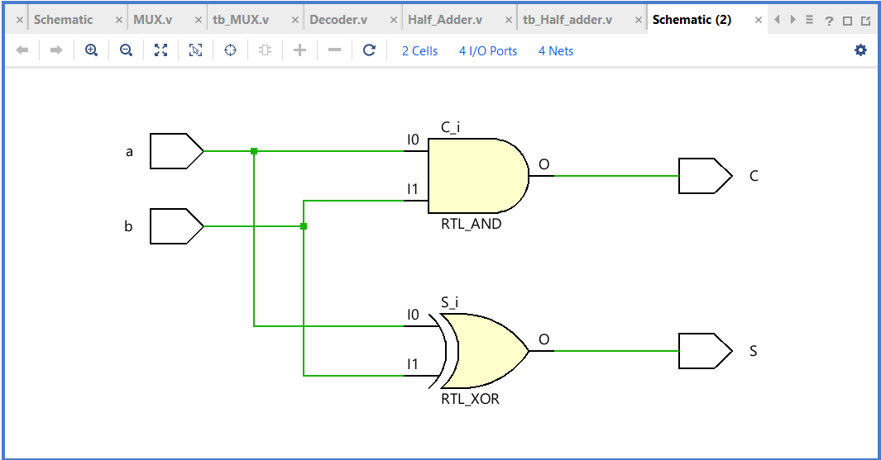
- Full Adder
Source Code:
`timescale 1ns / 1ps
module full_adder(
input a, b, cin,
output sum, cout
);
assign sum = a ^ b ^ cin;
assign cout = (a & b) | (b & cin) | (a & cin);
endmodule
Testbench Code:
`timescale 1ns / 1ps
module tb_full_adder;

reg a, b, cin;
wire sum, cout;

full_adder dut(a, b, cin, sum, cout);

initial begin
a=0; b=0; cin=0; #10;
a=1; b=0; cin=1; #10;
a=1; b=1; cin=0; #10;
a=1; b=1; cin=1; #10;
$finish;
end

endmodule
Simulation:
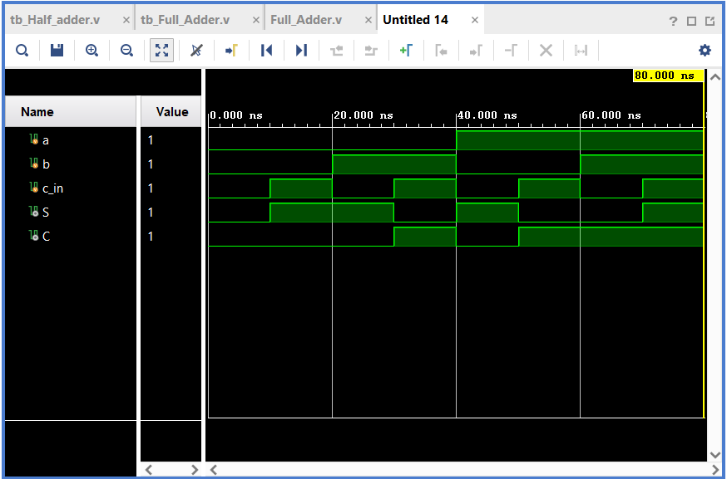
RTL Synthesis:
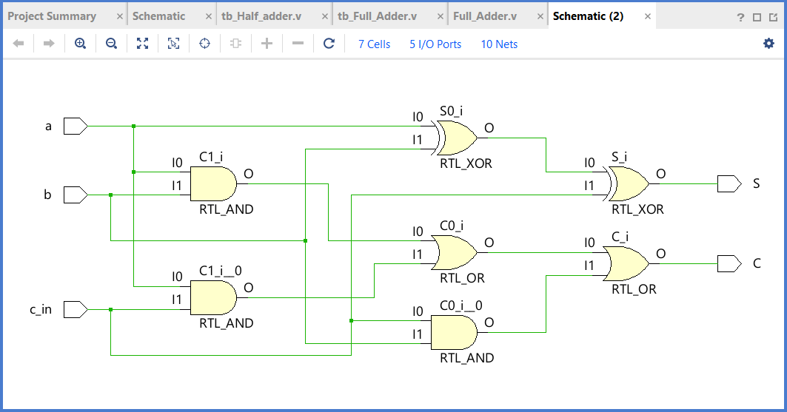
- Half Subtractor
Source Code:
`timescale 1ns / 1ps
module half_subtractor(
input a, b,
output diff, borrow
);
assign diff = a ^ b;
assign borrow = (~a) & b;
endmodule
Testbench Code:
`timescale 1ns / 1ps
module tb_half_subtractor;

reg a, b;
wire diff, borrow;

half_subtractor dut(a, b, diff, borrow);

initial begin
a=0; b=0; #10;
a=0; b=1; #10;
a=1; b=0; #10;
a=1; b=1; #10;
$finish;
end

endmodule
Simulation:
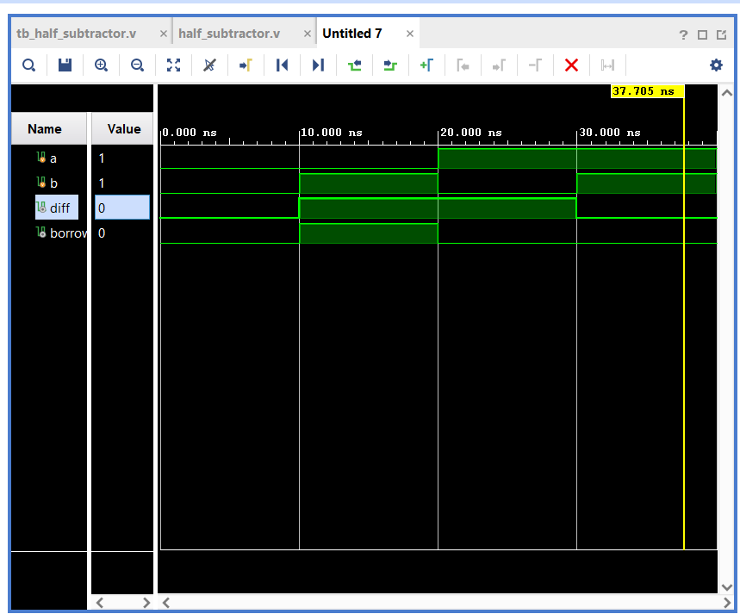
RTL Synthesis:
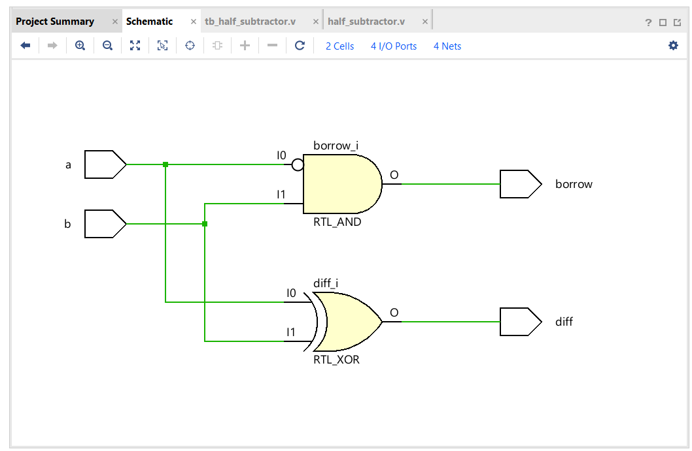
- Full Subtractor
Source Code:
`timescale 1ns / 1ps
module full_subtractor(
input a, b, bin,
output diff, bout
);
assign diff = a ^ b ^ bin;
assign bout = (~a & b) | (b & bin) | (~a & bin);
endmodule
Testbench Code:
`timescale 1ns / 1ps
module tb_full_subtractor;

reg a, b, bin;
wire diff, bout;

full_subtractor dut(a, b, bin, diff, bout);

initial begin
a=0; b=0; bin=0; #10;
a=1; b=0; bin=1; #10;
a=1; b=1; bin=0; #10;
a=1; b=1; bin=1; #10;
$finish;
end

endmodule
Simulation:
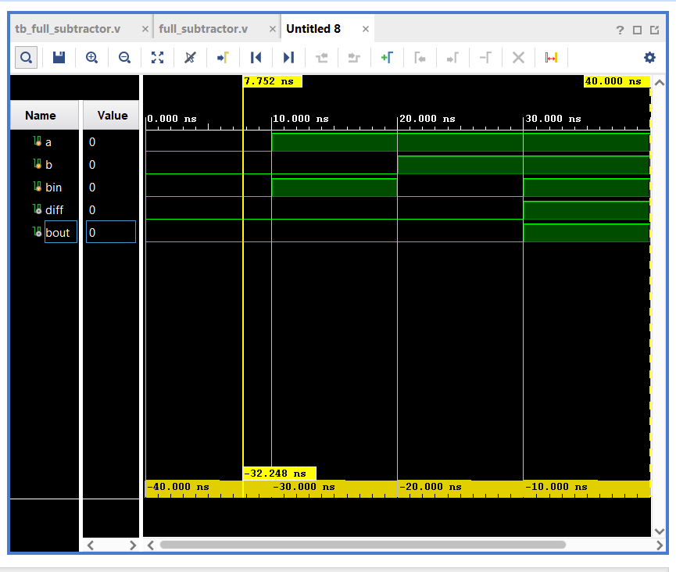
RTL Synthesis:
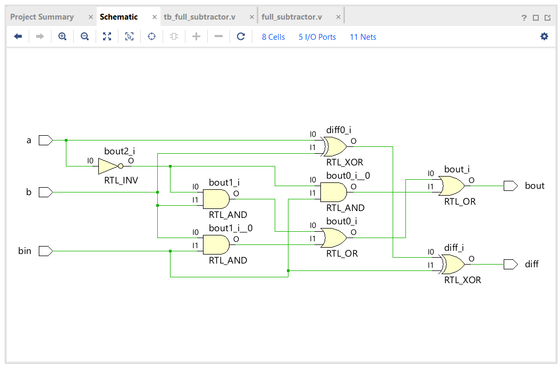
- Universal Adder / Subtractor with Overflow Check
Source Code:
`timescale 1ns / 1ps
module univ_adder_subtractor(
input [3:0] a, b,
input mode, // 0 = add, 1 = subtract
output [3:0] result,
output cout, overflow
);
wire [3:0] b_mod = mode ? ~b : b;
wire cin = mode;

assign {cout, result} = a + b_mod + cin;

assign overflow = (a[3] ~^ b_mod[3]) & (result[3] ^ a[3]);
endmodule
Testbench Code:
`timescale 1ns / 1ps
module tb_univ_adder_subtractor;

reg [3:0] a, b;
reg mode;
wire [3:0] result;
wire cout, overflow;

univ_adder_subtractor dut(a, b, mode, result, cout, overflow);

initial begin
a=4'b0101; b=4'b0011; mode=0; #10;
a=4'b0111; b=4'b1000; mode=0; #10;
a=4'b0110; b=4'b0001; mode=1; #10;
$finish;
end

endmodule
Simulation:
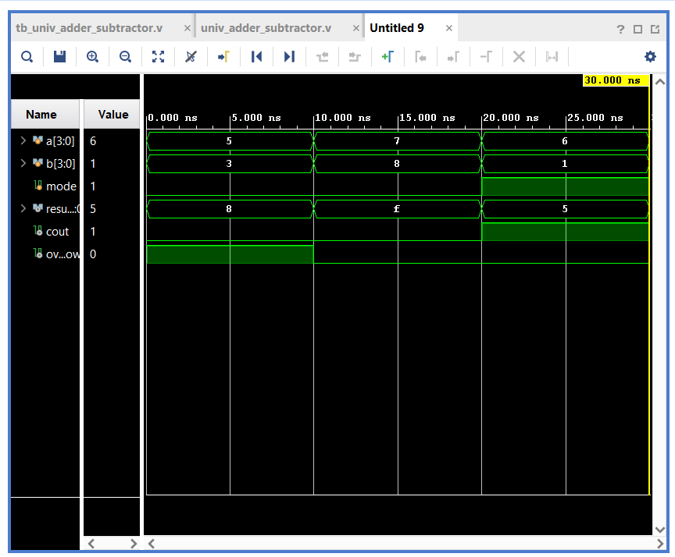
RTL Synthesis:
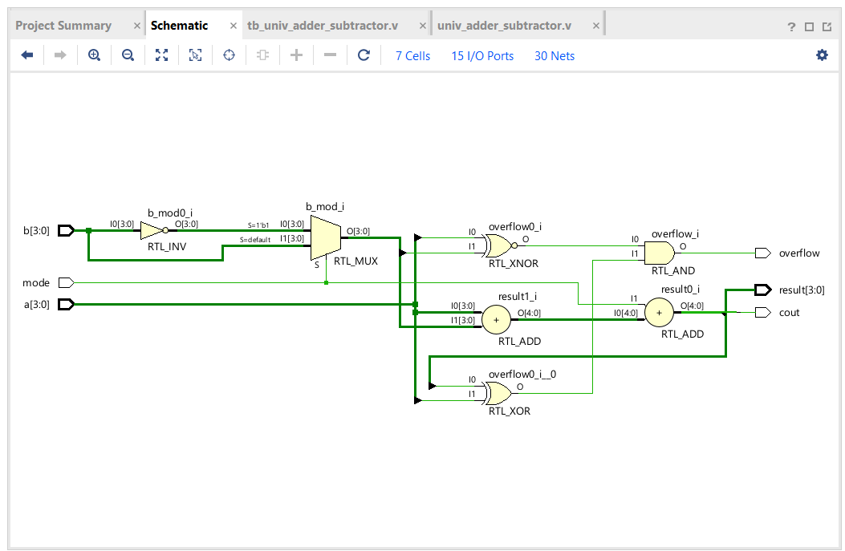
- SR Latch
Source Code:
`timescale 1ns / 1ps
module sr_latch(
input S, R,
output Q, Qbar
);
assign Q = ~(R | Qbar);
assign Qbar = ~(S | Q);
endmodule
Testbench Code:
`timescale 1ns / 1ps
module tb_sr_latch;

reg S, R;
wire Q, Qbar;

sr_latch dut(S, R, Q, Qbar);

initial begin
S=0; R=0; #10;
S=1; R=0; #10;
S=0; R=1; #10;
S=1; R=1; #10; // invalid
$finish;
end

endmodule
Simulation:
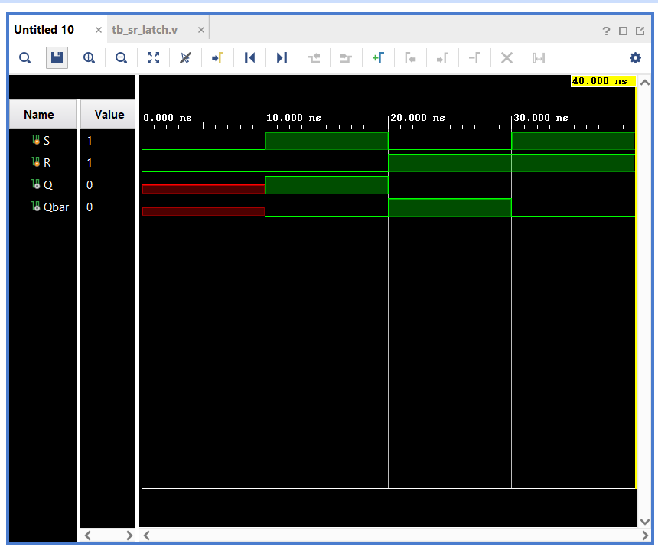
RTL Synthesis:
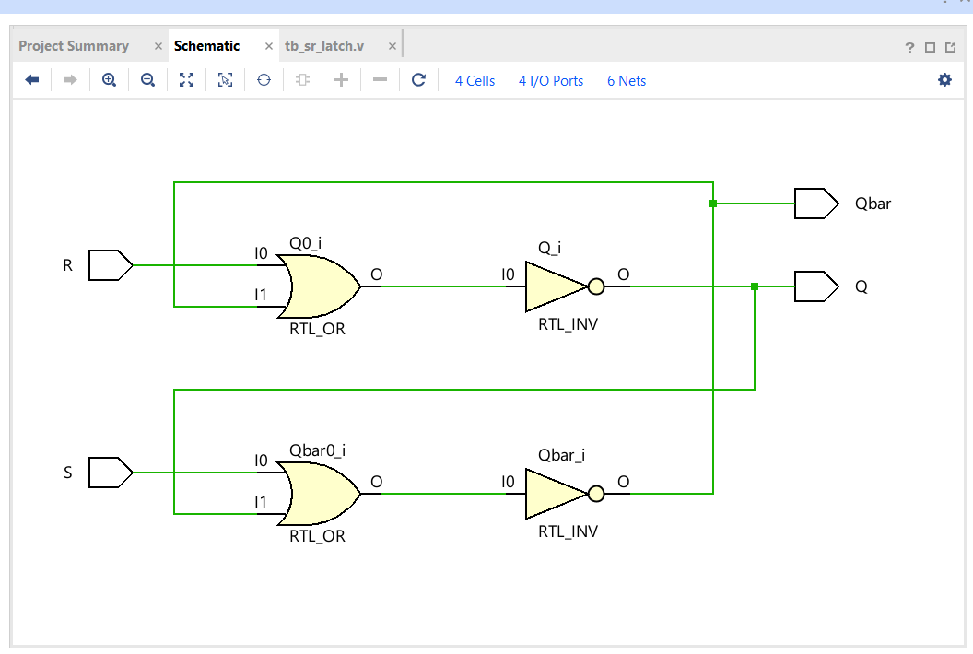
- SR - Flip Flop
Source Code:
`timescale 1ns / 1ps
module sr_ff(
input S, R, clk,
output reg Q
);
always @(posedge clk) begin
if (S && ~R) Q <= 1;
else if (R && ~S) Q <= 0;
else Q <= Q;
end
endmodule
Testbench Code:
`timescale 1ns / 1ps
module tb_sr_ff;

reg S, R, clk;
wire Q;

sr_ff dut(S, R, clk, Q);

initial clk = 0;
always #5 clk = ~clk;

initial begin
S=0; R=0; #10;
S=1; R=0; #10;
S=0; R=1; #10;
S=1; R=1; #10;
$finish;
end
endmodule
Simulation:
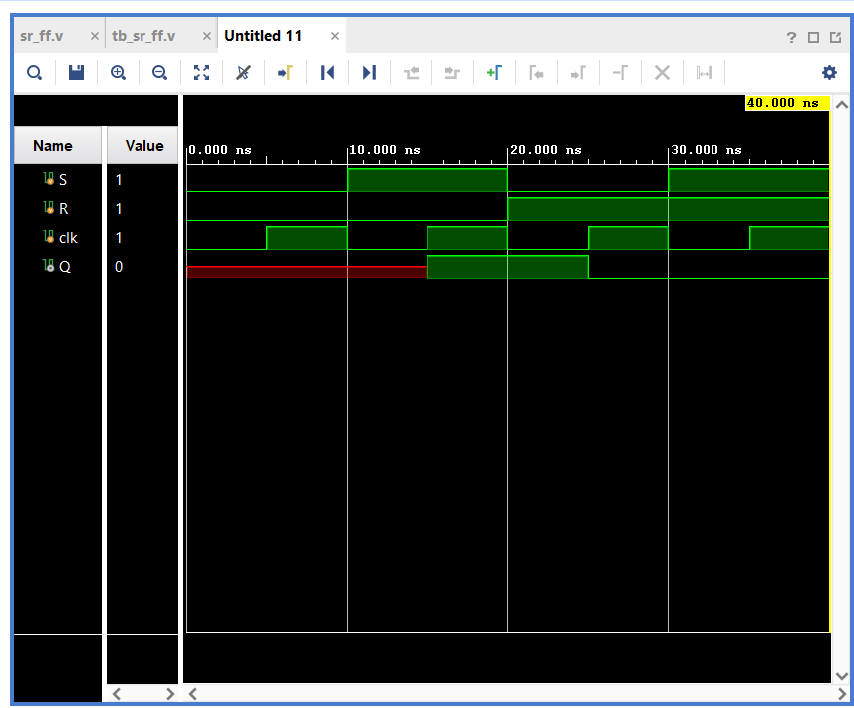
RTL Synthesis:
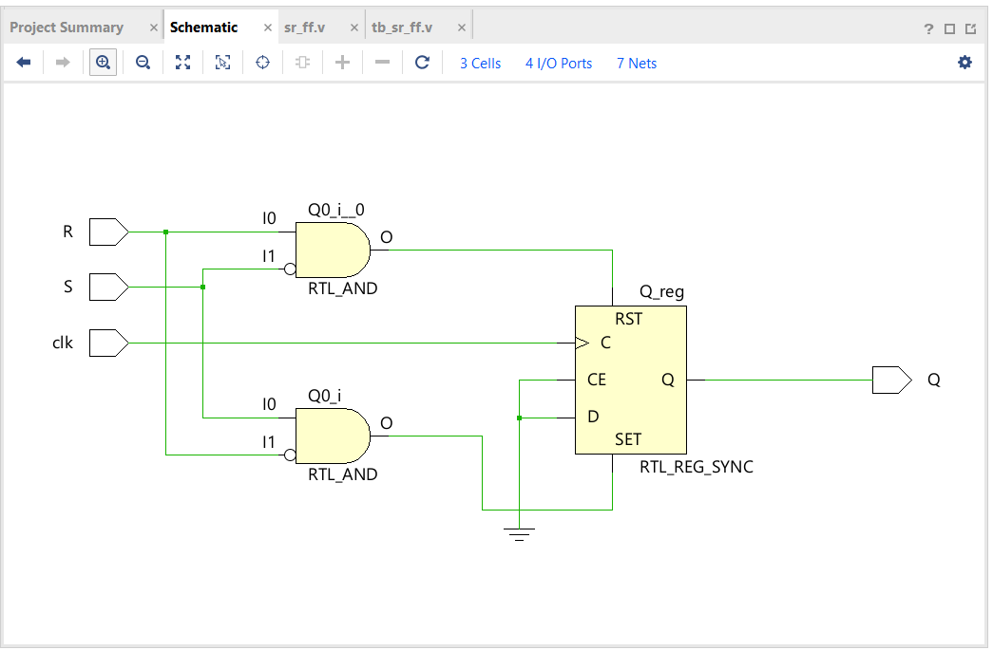
- JK - Flip Flop
Source Code:
`timescale 1ns / 1ps
module jk_ff(
input J, K, clk,
output reg Q
);
always @(posedge clk) begin
case ({J, K})
2'b00: Q <= Q;
2'b01: Q <= 0;
2'b10: Q <= 1;
2'b11: Q <= ~Q;
endcase
end
endmodule
Testbench Code:
`timescale 1ns / 1ps
module tb_jk_ff;

reg J, K, clk;
wire Q;

jk_ff dut(J, K, clk, Q);

initial clk=0;
always #5 clk = ~clk;

initial begin
J=0; K=0; #10;
J=1; K=0; #10;
J=0; K=1; #10;
J=1; K=1; #20;
$finish;
end

endmodule
Simulation:
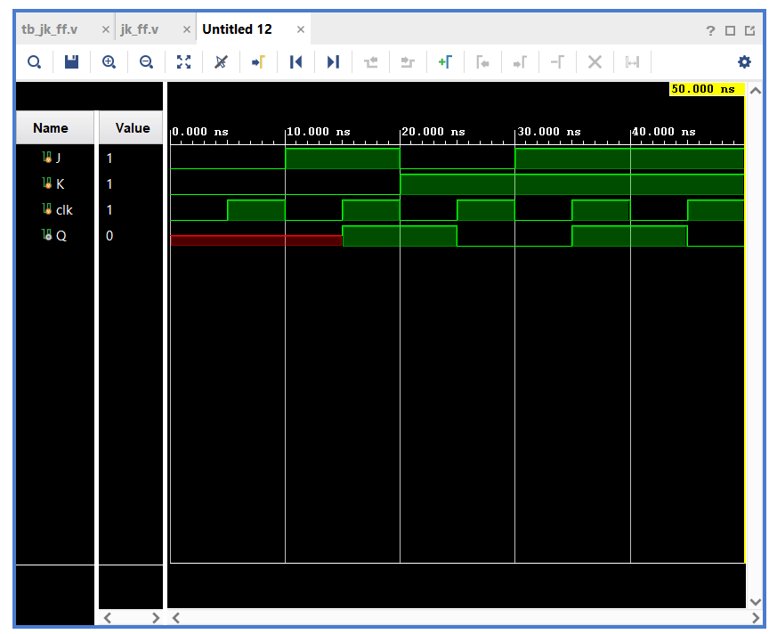

RTL Synthesis:
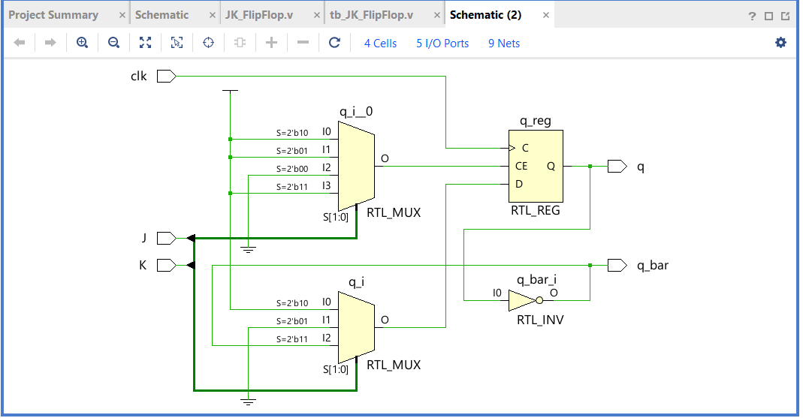
- D Flip Flop
Source Code:
`timescale 1ns / 1ps
module d_ff(
input D, clk,
output reg Q
);
always @(posedge clk)
Q <= D;
endmodule
Testbench Code:
`timescale 1ns / 1ps
module tb_d_ff;

reg D, clk;
wire Q;

d_ff dut(D, clk, Q);

initial clk = 0;
always #5 clk = ~clk;

initial begin
D=0; #10;
D=1; #10;
D=0; #10;
D=1; #10;
$finish;
end

endmodule
Simulation:
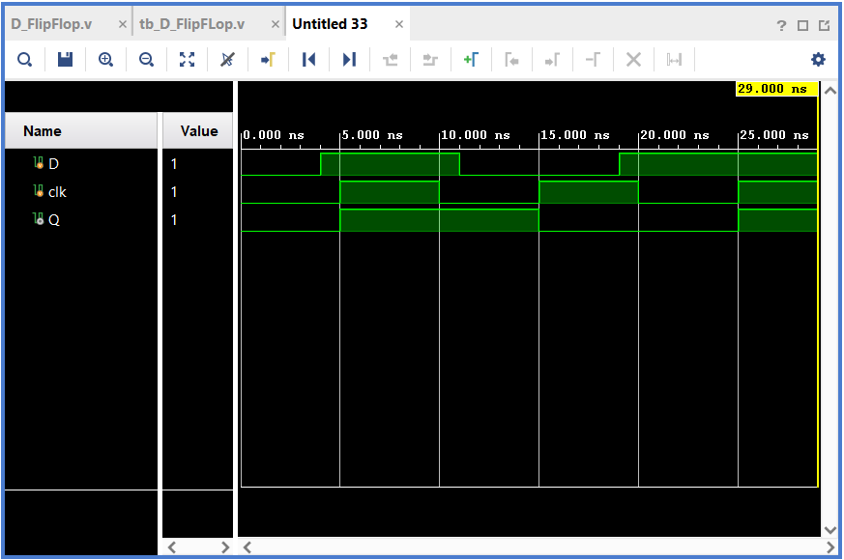
RTL Synthesis:
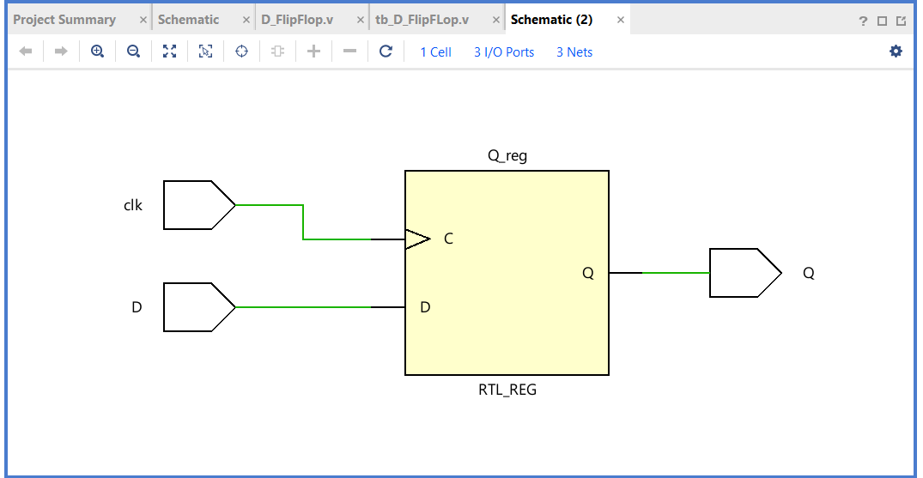
- T Flip Flop
Source Code:
`timescale 1ns / 1ps
module t_ff(
input T, clk,
output reg Q
);
always @(posedge clk) begin
if (T) Q <= ~Q;
else Q <= Q;
end
endmodule
Testbench Code:
`timescale 1ns / 1ps
module tb_t_ff;

reg T, clk;
wire Q;

t_ff dut(T, clk, Q);

initial clk = 0;
always #5 clk = ~clk;

initial begin
T=0; #10;
T=1; #10;
$finish;
end

endmodule
Simulation:
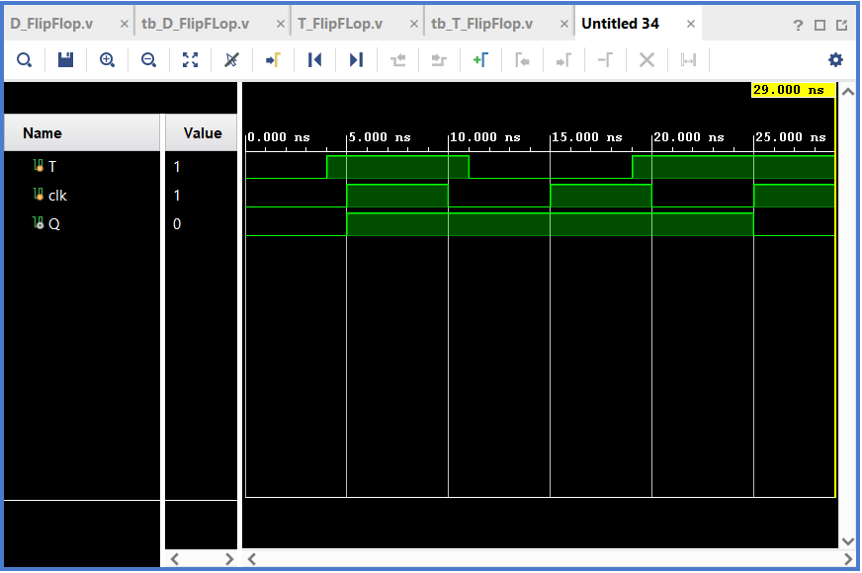
RTL Synthesis:
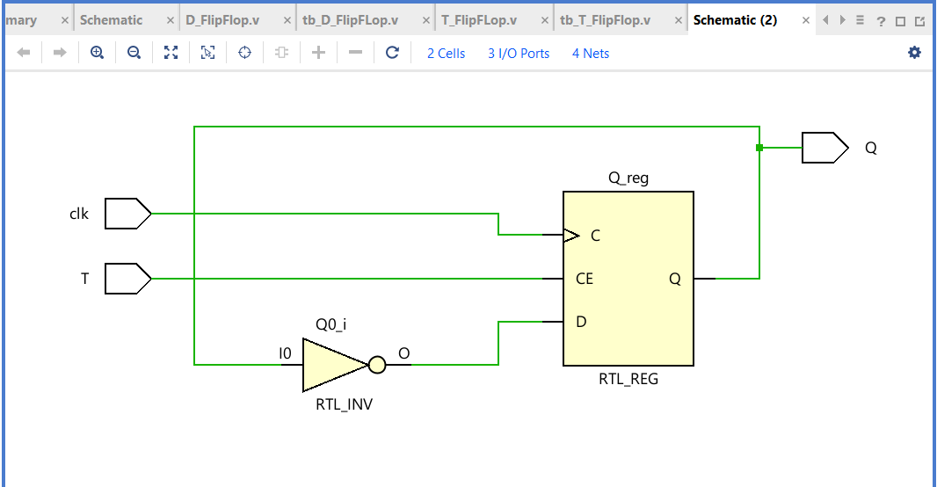
- Counter Design
Source Code:
`timescale 1ns / 1ps
module counter(
input clk,
input reset,
output reg [2:0] count
);

always @(posedge clk or posedge reset) begin
if (reset)
count <= 3'b000; // Start at 0
else begin
case (count)
3'b000: count <= 3'b011; // 0 → 3
3'b011: count <= 3'b101; // 3 → 5
3'b101: count <= 3'b110; // 5 → 6
3'b110: count <= 3'b000; // 6 → 0 (loop)

default: count <= 3'b000; // Lockout correction
endcase
end
end

endmodule
Testbench Code:
`timescale 1ns / 1ps
module tb_counter;

reg clk, reset;
wire [2:0] count;

counter dut(clk, reset, count);

initial clk = 0;
always #5 clk = ~clk;

initial begin
reset = 1; #10;
reset = 0;

// cycles - taken 200 ns
#200;

$finish;
end

endmodule
Simulation:
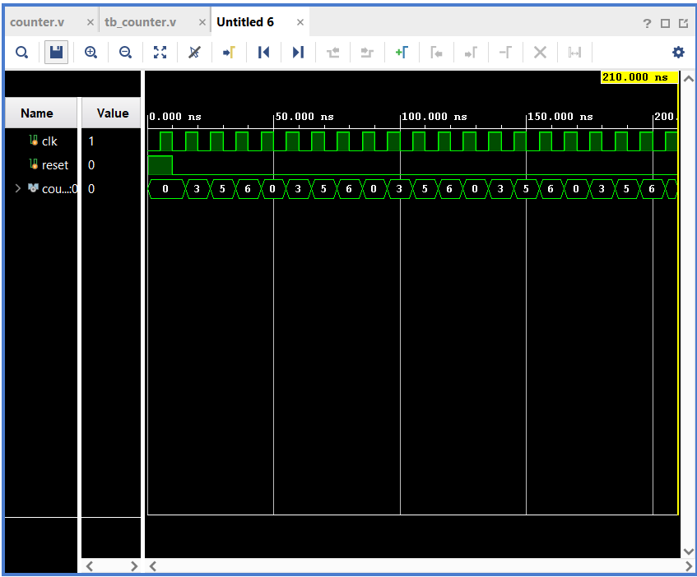
RTL Synthesis:
